

ROBOTIC ARM USING ESP32 MICROCONTROLLER
A PROJECT BASED LEARNING REPORT
Submitted by
DIVYADHARSAN S (22EC017)
HARIESH A (22EC023)
HARIHARAN T (22EC025)
HARIKRISHNAN N (22EC026)

In partial fulfilment for the award of the degree
of
BACHELOR OF ENGINEERING
ELECTRONICS AND COMMUNICATION ENGINEERING
NANDHA ENGINEERING COLLEGE, ERODE
(AUTONOMOUS)
(Affiliated to Anna University, Chennai)

December 2023

BONAFIDE CERTIFICATE
Certified that this project report “ROBOTIC ARM USING ESP32 MICROCONTROLLER” is the bonafide work of “DIVYADHARSAN S (22EC017), HARIESH A (22EC023), HARIHARAN T (22EC025), HARIKRISHNAN N (22EC023)”, who carried out the Project Based Learning work under my supervision.

SIGNATURE SIGNATURE
Ms. V. PARAMESHWARI, M.E, M.B.A.,(Ph.D) Dr.S.KAVITHA, M.E., Ph.D,
Assistant Professor/ECE, Professor and Head of the Department,
PBL COORDINATOR, Department of ECE,
Department of ECE, Nandha Engineering College,
Nandha Engineering College, (Autonomous),
(Autonomous), Erode-638052.
Erode-638052.

ACKNOWLEDGEMENT
The success of a work depends on the team work and co-operation various involved either directly or indirectly.
We express our thanks to our beloved Chairman of Sri Nandha Educational Trust Thiru.V.SHANMUGAN and our beloved Secretary, Thiru.S.THIRUMOORTHI of Nandha Engineering College for providing us all the basic amenities to complete the course successfully.
We wish to express our deep sense of gratitude and thanks to our beloved Principal Dr.N.RENGARAJAN ,for the excellent facilties providing during the course study and project work.
We wish to express our hearty thanks to Dr.S.KAVITHA, Professor & Dean, Dr.C.N.MARIMUTHU, Professor & Dean(R&D), Department of Electronics and Communication Engineering for providing support during the project work.
We are highly indebted to our project guide Ms. V. PARAMESHWARI Assistant Professor and Mr.M.SRINEVASAN, Assistant Prefesser, Project Lab Incharge, Department of Electronics and Communication Engineering, for their guidance and motivation in completing the project.
We thank all the Teaching and non-Teaching staff members of Electronics and Communication Engineering Department for their support to our project work. we also express our thanks to our family members and friends for their encouragement timely help and suggestion

TITLE OF CONTENT
CHAPTER NO | TITLE  ABSTRACT | PAGE NO  5
1 | INTRODUCTION | 6
2  3  4  5  6 | COMPONENTS REQUIRED  2.1 HARDWARE REQUIRED  2.1.1 ESP32 microcontroller  2.1.2 Servo motor driver  2.1.3 Jumping wire  2.1.4 Servo motor  2.2 SOFTWARE REQUEIRED  2.2.1 Arduino IDE  2.2.2 Program Coding  BLOCK DIAGRAM  3.1 Circuit diagram  3.2 Working  CONCLUSION  FUTURE SCOPE  REFERENCE  APPENDIX | 7  7  7  9  9  10  11  11  11  13  13  14  15  15  16  16

ABSTRACT:

This project showcases the development of a robotic arm utilizing the ESP32 microcontroller for streamlined control and precision movements. The ESP32's wireless capabilities enable real-time communication with the arm, managed through an intuitive user interface. The system incorporates sensors for enhanced accuracy, ensuring precise and adaptable arm maneuvers. Its modular design promotes easy customization, making it suitable for various applications, including educational settings and hobbyist projects. This cost-effective solution leverages the ESP32's efficiency, opening avenues for remote, automated, and programmable operations. This project not only demonstrates the possibility of ESP32 in robotic applications but also offers a foundation for further advancements in the integration of microcontrollers for sophisticated control in robotics.

CHAPTER 1

INTRODUCTIONS:

In this project, the integration of intelligent microcontrollers has revolutionized the capabilities of robotic systems. One such example is the development of a Robotic Arm powered by the ESP32 microcontroller. This project combines the precision and versatility of a robotic arm with the computational power and connectivity features of the ESP32, resulting in a sophisticated and programmable robotic system. The core of the project is the robotic arm itself, comprising joints and actuators designed for precise and controlled movement. The robotic arm is capable of executing a variety of tasks, making it suitable for applications ranging from industrial automation to educational purposes. Leveraging the ESP32's wireless capabilities, the robotic arm can be controlled remotely through a user interface, either via Wi-Fi or Bluetooth. This allows for flexible operation and programming without the need for physical connections. The ESP32's programmability allows users to create custom control sequences and automation scripts for the robotic arm. This feature is particularly valuable for researchers, hobbyists, and educators seeking to explore the potential of robotic systems. The project can be extended to integrate the robotic arm into the Internet of Things (IoT) ecosystem. This opens up possibilities for cloud-based control, data logging, and remote monitoring, making the robotic arm a versatile and connected device. This introduction sets the stage for a deep dive into the technical aspects of the robotic arm controlled by the ESP32. The fusion of robotics and advanced microcontroller technology exemplifies the evolving landscape of intelligent automation, offering a glimpse into the future of interconnected and programmable robotic systems.

CHAPTER 2
COMPONENTS REQUIRED :
1. HARDWARE REQUIRED:
1.1 ESP32 microcontroller
1.2 Servomotor driver
1.3 Jumping wires
1.4 Servo motor
2. SOFTWARE REQUEIRED :
2.1 Arduino IDE
2.2 Program Coding

1. HARDWARE REQUIRED:
1.1 ESP32 MICROCONTROLLER:
The ESP32 microcontroller is a powerful and versatile chip developed by Espressif Systems. It is part of the ESP (Espressif Systems Platform) family, and it has gained significant popularity in the maker, hobbyist, and IoT (Internet of Things) communities due to its impressive features and capabilities. Here are some key aspects of the ESP32 microcontroller. The ESP32 microcontroller is a powerful and versatile chip developed by Espressif Systems. It is part of the ESP (Espressif Systems Platform) family, and it has gained significant popularity in the maker, hobbyist, and IoT (Internet of Things) communities due to its impressive features and capabilities. Here are some key aspects of the ESP32 microcontroller
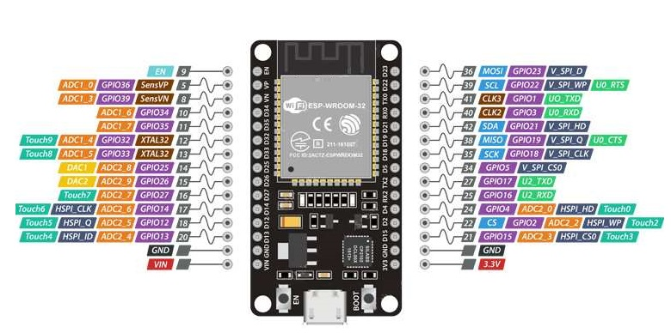
Fig 2.1: ESP32 Pin Configuration

One of the standout features of the ESP32 is its built-in Wi-Fi and Bluetooth connectivity. This makes it suitable for a wide range of applications where wireless communication is essential, such as IoT devices, home automation, and industrial applications.
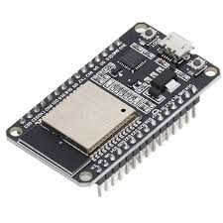
Fig 2.2: ESP32 wifi bt

1.2 SERVO MOTOR DRIVER
A servo motor driver, often referred to as a servo motor controller or amplifier, is a device that interfaces with a servo motor to precisely control its movements. The driver interprets control signals and amplifies them to provide the necessary power to the servo motor.
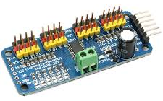

Fig 2.3: servo motor driver

1.3 JUMPING WIRES :
A jump wire (also known as jumper, jumper wire, DuPont wire) is an electrical wire, or group of them in a cable, with a connector or pin at each end (or sometimes without them – simply “tinned”), which is normally used to interconnect the components of a breadboard or other prototype or test circuit, internally or with other equipment or components, without soldering. Individual jump wires are fitted by inserting their “end connectors” into the slots provided in a breadboard, the header connector of a circuit board, or a piece of testequipment.
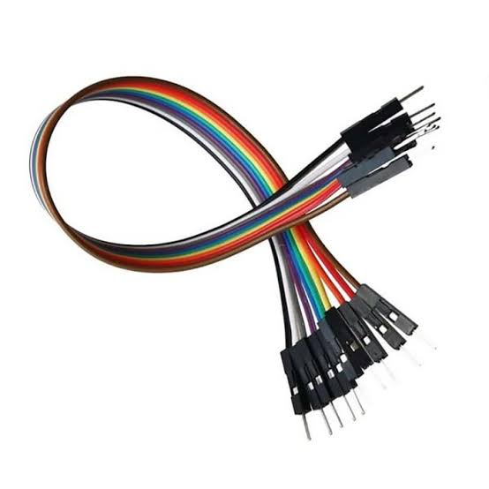

Fig 2.4: jumping wires

1.4 SERVO MOTOR:
One of the standout features of the ESP32 is its built-in Wi-Fi and Bluetooth connectivity. This makes it suitable for a wide range of applications where wireless communication is essential, such as IoT devices, home automation, and industrial applications.
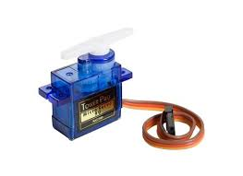

Fig 2.5: servo motor
2. SOFTWARE REQUEIRED :
2.1 ARDUINO IDE :
The new major release of the Arduino IDE is faster and even more powerful! In addition to a more modern editor and a more responsive interface it features autocompletion, code navigation, and even a live debugger.
2.2 PROGRAM CODING :
#define BLYNK_PRINT Serial
#include <Wire.h>
#include <Adafruit_PWMServoDriver.h>
#include <WiFiClient.h>
#include <BlynkSimpleEsp32.h>
Adafruit_PWMServoDriver srituhobby = Adafruit_PWMServoDriver(0x40);
#define servoMIN 150
#define servoMAX 600
// Enter your Auth token
char auth[] = "*************";
//Enter your WIFI SSID and password
char ssid[] = "***********";
char pass[] = "*************";
BLYNK_WRITE(V0)
{
int value = param.asInt();
value = map(value, 0, 180, servoMIN, servoMAX);
srituhobby.setPWM(0, 0, value);
delay(1);
}
BLYNK_WRITE(V1)
{
int value = param.asInt();
value = map(value, 0, 180, servoMIN, servoMAX);
srituhobby.setPWM(1, 0, value);
delay(1);
}
BLYNK_WRITE(V2)
{
int value = param.asInt();
value = map(value, 0, 180, servoMIN, servoMAX);
srituhobby.setPWM(2, 0, value);
delay(1);
}
BLYNK_WRITE(V3)
{
int value = param.asInt();
value = map(value, 0, 180, servoMIN, servoMAX);
srituhobby.setPWM(3, 0, value);
delay(1);
}
void loop()
{
Blynk.run();
}
CHAPTER 3
BLOCK DIAGRAM OF PROPOSED SYSTEM:
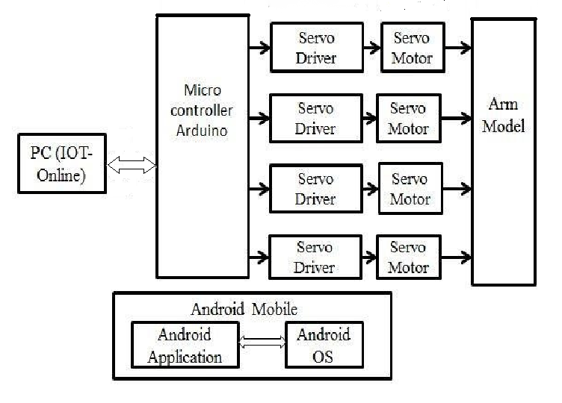
Fig 3.1: Block diagram of proposed system
CIRCUIT DIAGRAM OF PROPOSED SYSTEM:
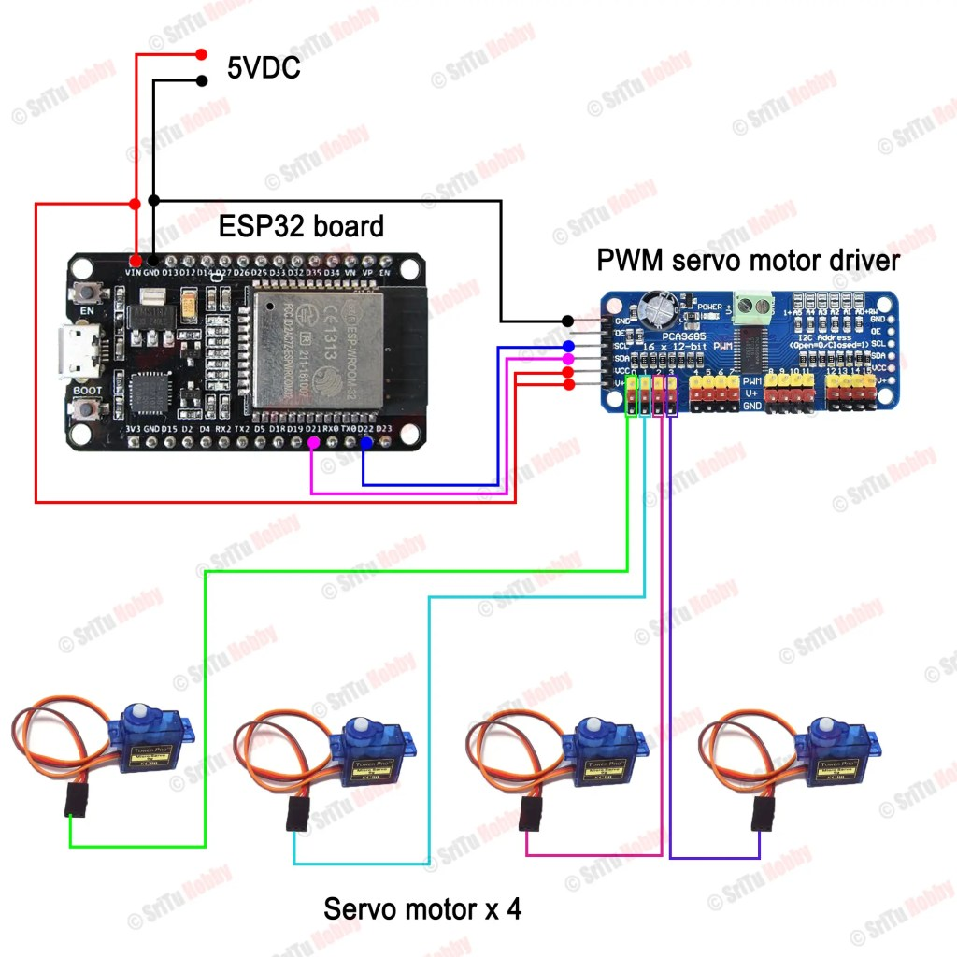
Fig 3.2: Circuit diagram of proposed system
WORKING OF ROBOTIC ARM:
- The working of a robotic arm using ESP32 involves the integration of the ESP32 microcontroller with the robotic arm's hardware components to control its movement and functionalities. The robotic arm consists of mechanical components such as joints, actuators, and end-effectors. These components enable the arm to move in a controlled manner and perform tasks. The robotic arm is equipped with sensors to provide feedback on the arm's position and orientation.
- The ESP32 microcontroller is integrated into the robotic arm system as the central control unit. Its compact size, processing power, and built-in wireless capabilities make it suitable for real-time control and communication. Servo motors or other types of motors are used in the robotic arm for actuation. The ESP32 sends control signals to these motors to regulate their speed and position. The closed-loop feedback system ensures that the arm moves accurately according to the desired positions.
- The ESP32's built-in Wi-Fi or Bluetooth capabilities are utilized for wireless communication. This allows the robotic arm to be controlled remotely, either through a dedicated user interface (UI) on a computer, a mobile app, or any device capable of sending commands to the ESP32. A user interface is developed to interact with the robotic arm. This could be a custom software application, a web-based interface, or a mobile app. The UI allows users to send commands to the ESP32, specifying the desired movements, angles, or tasks for the robotic arm. Control Algorithms: The ESP32 runs control algorithms to interpret the user's commands and convert them into signals that control the motors. These algorithms may include inverse kinematics calculations to determine the required joint angles for achieving a specific end-effector position. Sensors integrated into the robotic arm provide feedback to the ESP32 about the arm's current position, speed, and other relevant data. This feedback is crucial for the closed-loop control system, allowing the microcontroller to make real-time adjustments to ensure precise movements.
- The ESP32's programmability allows users to create custom sequences, automate tasks, and program the robotic arm for specific applications. This capability is valuable for research, education, and industrial automation where specific movements or sequences are required. If desired, the ESP32 can be further integrated into the Internet of Things (IoT) ecosystem. This allows for remote monitoring, data logging, and cloud-based control of the robotic arm.

CHAPTER 4

CONCLUSION:
In conclusion, the integration of a robotic arm with the ESP32 microcontroller represents a powerful and versatile solution for achieving precise and controlled motion in various applications. The combination of the robotic arm's mechanical components and the ESP32's computational capabilities opens up a wide range of possibilities for automation, remote control, and customization.

CHAPTER 5
FUTURE SCOPE:
- The future scope for robotic arms using ESP32 envisions a paradigm shift in automation and robotics, with an emphasis on intelligence, adaptability, and collaboration.
- As technology advances, we anticipate the integration of more advanced sensors, such as computer vision and tactile sensors, to enhance the robotic arm's perception and interaction capabilities.
- AI-driven control algorithms will enable these arms to learn and optimize their movements, adapting to dynamic environments and complex tasks.
- Collaboration between humans and robotic arms will be a focal point, with enhanced safety features and intuitive interfaces allowing for seamless interaction.
- The use of multiple robotic arms working collaboratively, possibly in swarm configurations, is likely to become more prevalent, increasing efficiency in industrial applications.
- Cloud connectivity and edge computing integration will enable offloading computational tasks, facilitating remote monitoring, and execution of complex operations.
- Furthermore, the modular design of these robotic arms will provide customization options, making them adaptable to diverse industries and applications, from healthcare assistance to intricate manufacturing processes. In education and research, ESP32-based robotic arms will serve as accessible platforms, fostering innovation and exploration in robotics.
- Overall, the future of robotic arms using ESP32 envisions a transformative era where intelligent, connected, and versatile robotic systems redefine the landscape of automation and human-machine collaboration.
CHAPTER 6
REFERENCE:
https://youtu.be/un_4Xf1gFKM?si=uyKS7nvZTeYwrIv6
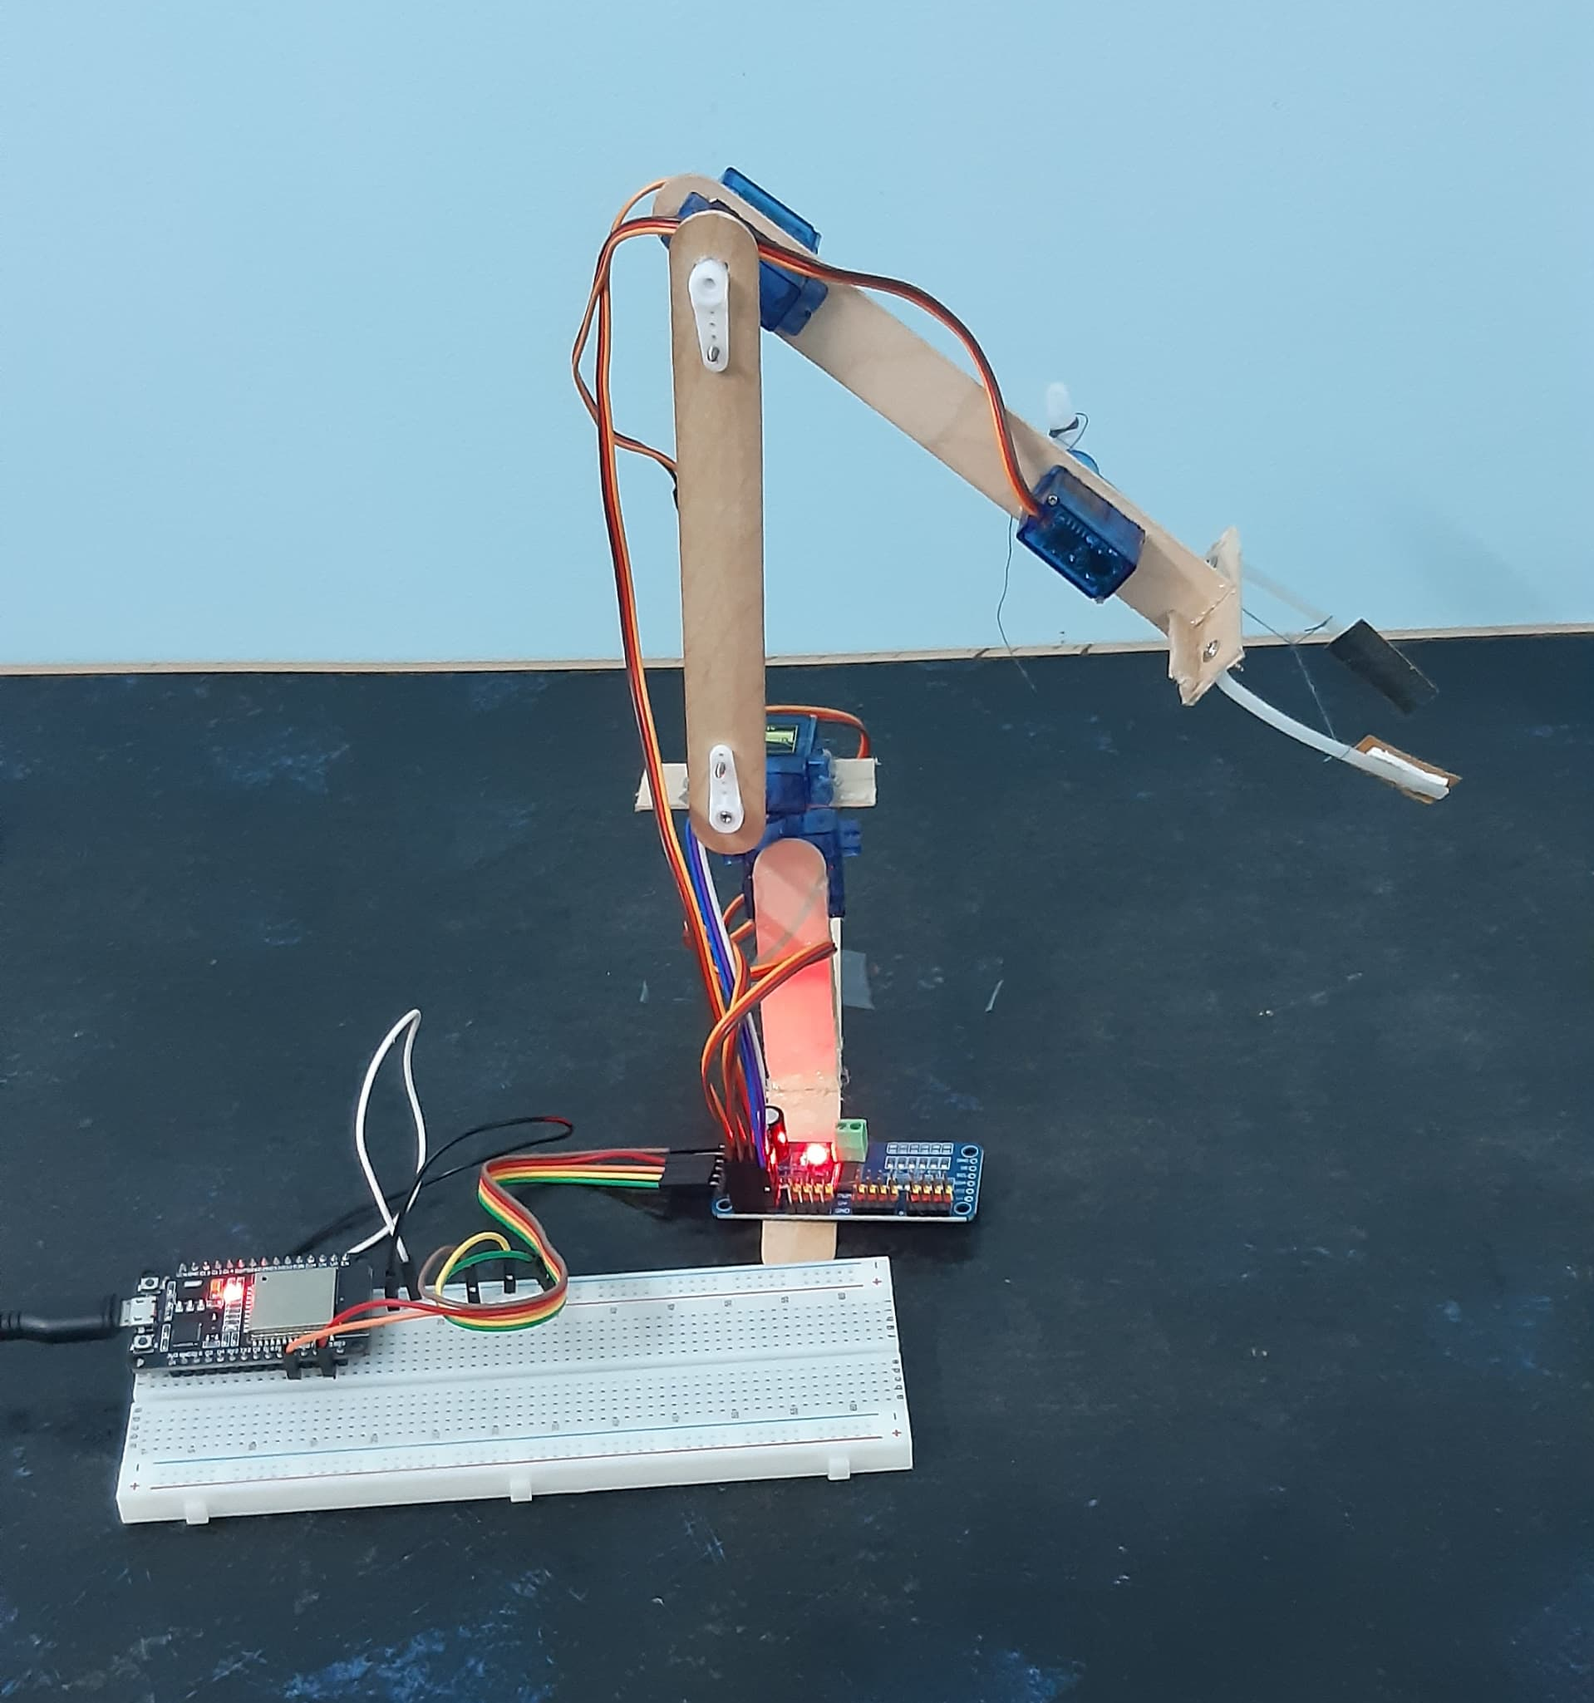
APPENDIX
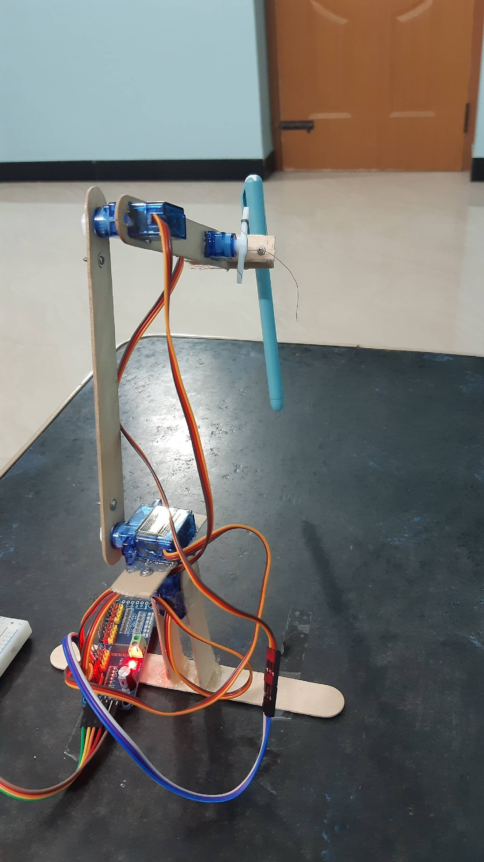
Fig 6.1: Back view Fig 6.2: Side view
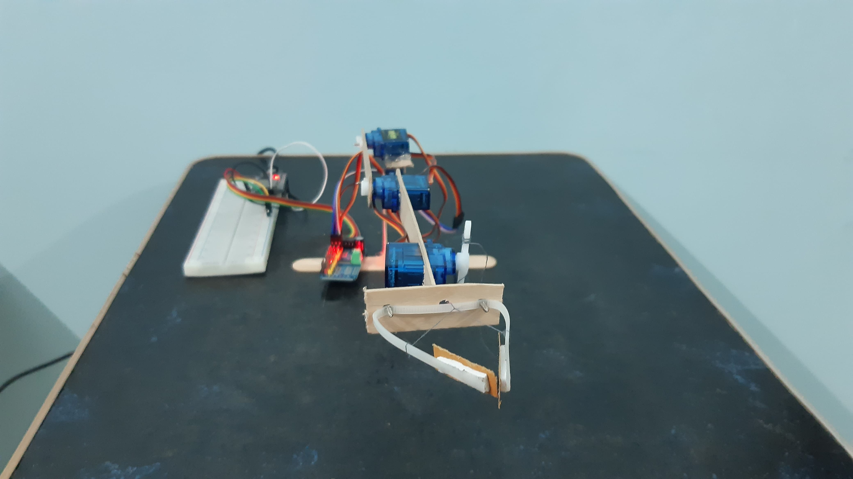
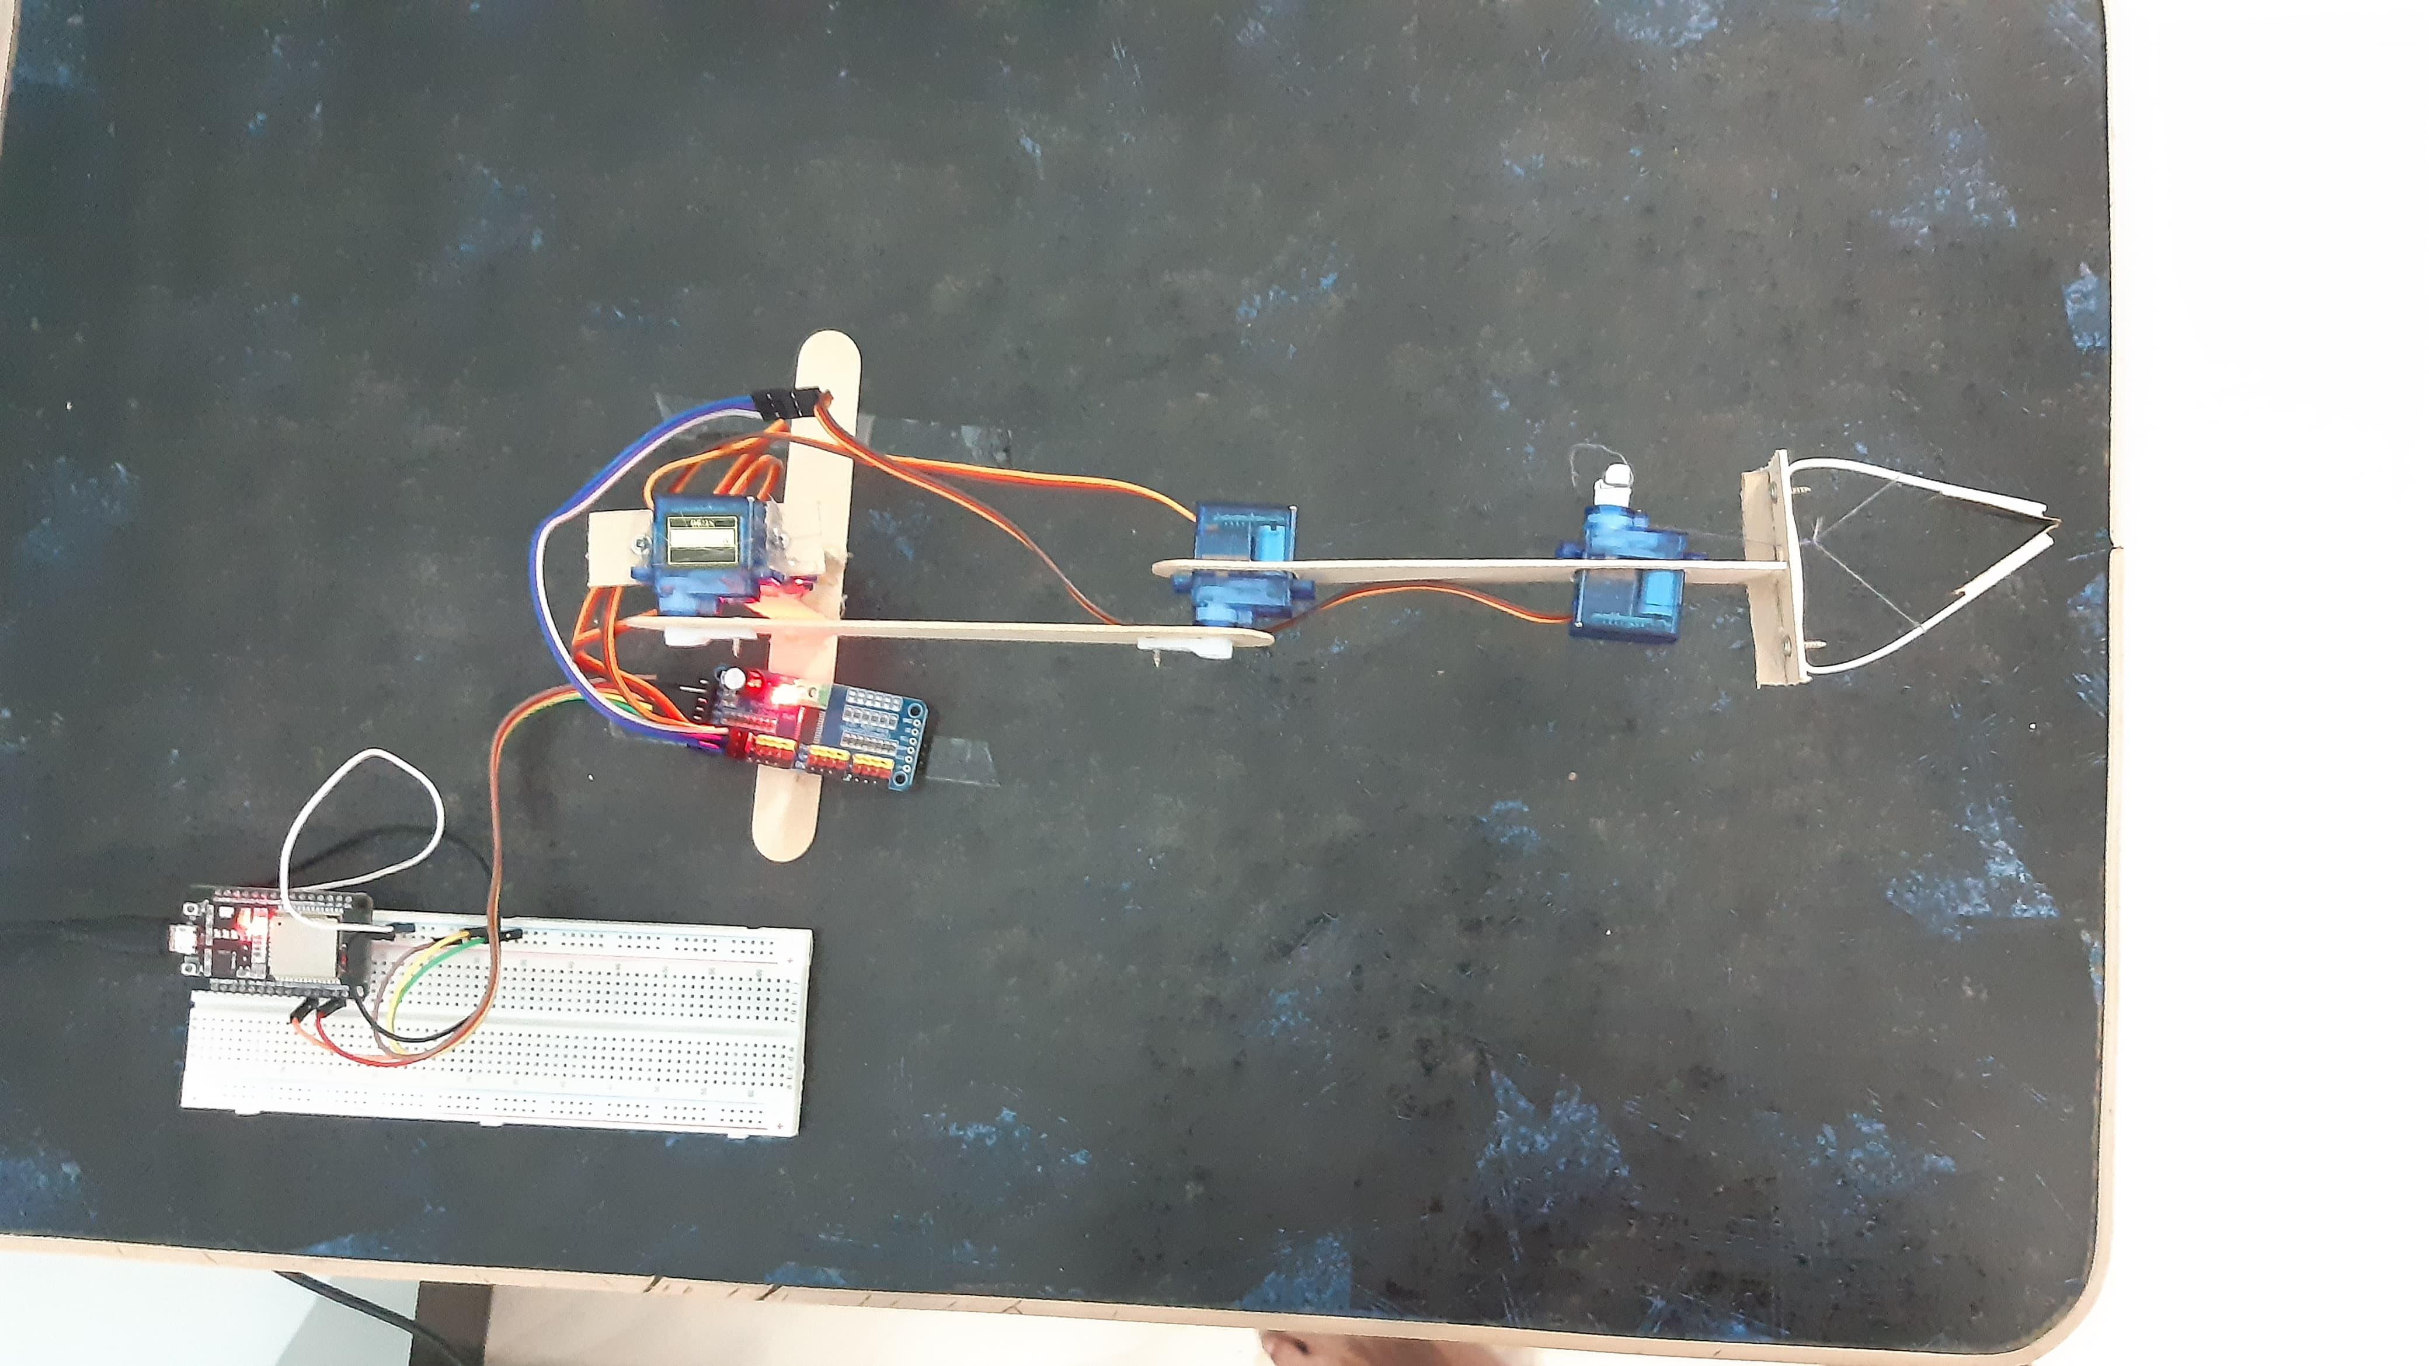
Fig 6.3: Front view Fig 6.4: Top view

HARDWARE OF THE PROJECT

